Answers to H1 Chemistry Prelims Paper 1

1. | B | 6. | A | 11. | D | 16. | C | 21. | D | 26. | C
2. | C | 7. | D | 12. | A | 17. | B | 22. | B | 27. | B
3. | B | 8. | A | 13. | D | 18. | C | 23. | C | 28. | A
4. | C | 9. | C | 14. | D | 19. | B | 24. | C | 29. | C
5. | C | 10. | B | 15. | B | 20. | A | 25. | D | 30. | A

Suggested Answers to H1 Chemistry Prelims Paper 2

Section A

1. | (a) | Dot and cross diagram for hydrazine:  N  ×  o  N  ×  ×  ×  o  H  ×  o  H  o  o  o  ×  o  ×  H  H  107º  Shape of molecule: Trigonal pyramidal  Bond angle of H−N−H: 107º
 | (b) | N₂H₅⁺(aq) + H₂O (l) 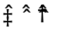N₂H₄(aq) + H₃O⁺(aq)  N₂H₅⁺ is able to hydrolyse in water to give acidic protons /  N₂H₅⁺ is the conjugate acid of N₂H₄.
 | (c) | NO₃⁻(aq) + 4H⁺(aq) + 3e⁻ ⎯→ NO(g) + 2H₂O(l)  N₂H₄(l) → N₂(g) + 4H⁺(aq) + 4e⁻  Overall balanced equation:  4NO₃⁻(aq) + 4H⁺(aq) + 3N₂H₄(l) ⎯→ 4NO(g) + 8H₂O(l) + 3N₂(g)
 | (d) | Enthalpy change of reaction  = [4(−394) + 12(−242)] – [5(−20) + 4(+53)]  = −4590 kJ mol⁻¹ (3 s.f.)
 | (e) | Diphosphine molecules experience permanent dipole-permanent dipole forces of interactions whereas hydrazine molecules experience intermolecular hydrogen bonding. It requires more energy to overcome hydrogen bonding as compared to permanent dipole-permanent dipole forces of attraction.
 | (f) | Structure of carbonyl compound:  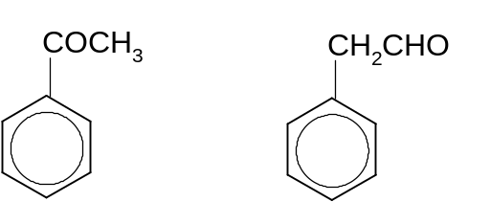  or  Type of reaction in Step I: condensation
2. | (a) | (i) | Group I. Largest increase in energy to remove the second outermost electron.  X could be potassium.
 |  | (ii) | K₂O + H₂O ⎯→ 2KOH or X₂O + H₂O ⎯→ 2XOH  Acceptable answer: pH 12 to 14.
 | (b)  Electrical Conductivity  Na Mg Al Si P S Cl  0 | Ionic Radius  Na Mg Al Si P S Cl  Do not mark for Si.
3. | (a) | ‘Standard enthalpy change of neutralisation’ is the heat change when an amount of acid neutralises a base to form 1 mole of water (in dilute aqueous solution) at 298 K and 1 atmosphere pressure.
 | (b) | (i) | Amount of Ba(OH)₂ added  = 30.0 x 10⁻³ x 0.40  = 0.012 mol  ∴ amount of OH⁻ added  = 2 x 0.012  = 0.024 mol  Amount of H⁺ added  = amount of HCl added  = 40.0 x 10⁻³ x 0.80  = 0.032 mol  ∴ HCl is in excess.  Amount of water formed from acid-base reaction  = 0.024 mol  Heat evolved from reaction = (30.0 + 40.0) x 4.3 x 4.0 = 1204 J  Enthalpy change of neutralisation  = 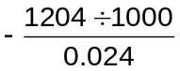= −50.2 kJ mol⁻¹ (sign and correct units)
 |  | (ii) | Heat energy was lost during the experiment and hence, the experimental errors led to the difference in the calculated value from the theoretical value.  OR  - The density of water is used as an approximate to the density of the solution.  - The specific heat capacity of the water is used as an approximate to the specific heat capacity of the solution.
 | (c) | (i) | Energy  E_{a} =79 kJ mol⁻¹  H₂O₂  ΔH = - 98 kJ mol⁻¹  H₂O + ½ O₂  Reaction Coordinate
 |  | (ii) | Enzymes are proteins which act as biological catalysts which speed up the reaction by providing an alternative pathway that lowers the activation energy of the reaction such that more molecules now have energy greater than or equal to E_{a}’ (catalysed reaction).
4. | (a) | The C=C double bond restricts free rotation about the double bond. There are 2 different adjacent groups attached to each of the doubly bonded carbon.
 | (b) | (i) | Step I – reduction
 |  | (ii) | 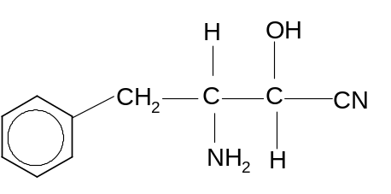
 |  | (iii) | HCN is a weak acid which dissociates partially:  HCN(aq) 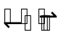H⁺(aq) + CN⁻(aq)  Adding a trace amount of base will remove H⁺ and shifts the position of the equilibrium to the right to increase the concentration of CN⁻. The rate increases with increasing concentration of CN⁻.
5. | (a) | 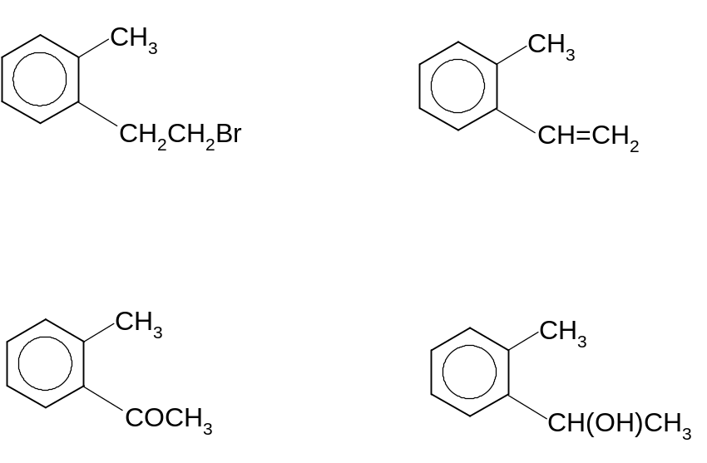  K₂Cr₂O₇, H₂SO₄,  heat  Do not award marks if KMnO₄ is used.  ethanolic NaOH,  heat  1) Cold conc. H₂SO₄  2) Warm with H₂O
 | (b) | 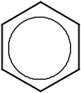  FeBr₃  Or any other  suitable catalyst  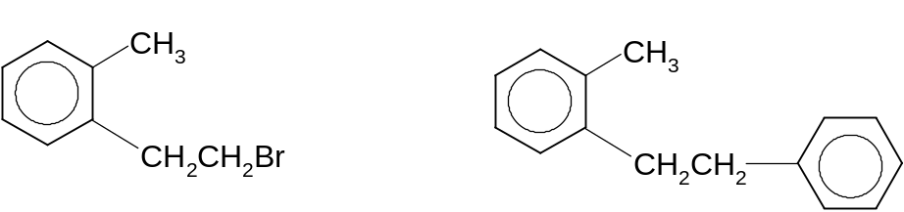  + HBr

Section B

6. |  | (a) |  | (i) |  | Lattice energy of NaCl  = ΔH₁ - ΔH₂ - ΔH₃ - ΔH₄ - ΔH₅  = −776 – (109) – (244) – 494 – (−364)  = −1260 kJ mol⁻¹
 |  |  |  | (ii) |  | ΔH₁ – Enthalpy change of formation of NaCl(s)  ΔH₄ – First ionisation energy of Na(g)
 |  |  |  | (iii) |  | Lattice energy ∝ 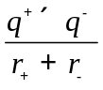  The lattice energy of MgCl₂ will be more exothermic compared to that of NaCl. This is because the Mg²⁺ ion has a higher charge and smaller ionic radius/ higher charge density compared to Na⁺ ion.
 |  | (b) |  | Empirical fomula of P is C₄H₉Br, since M_{r} is 136.9, the molecular fomula is C₄H₉Br.  Explanation:  - P reacts via substitution with aq. sodium hydroxide to give Q. Q is likely to be an alcohol.  - Q on oxidation gives R, which forms orange ppt with 2,4-dinitrophenylhydrazine via condensation. R is a carbonyl compound.  - Positive iodoform test with Q and R. Q has the structure –CH(OH)(CH₃) while R has the structure : 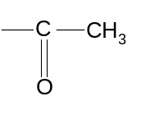  - P undergoes elimination with hot ethanolic NaOH to give V, W and X. V, W and X are likely to be alkenes.  Structure of P:  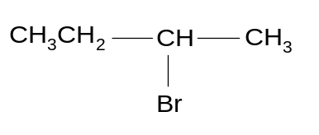  Structure of Q:  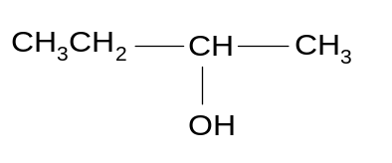  Structure of R:  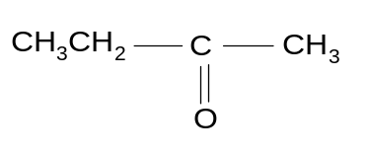  Structure of V, W and X:  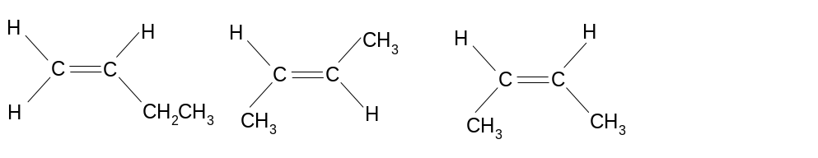  Cis & Trans Isomers
 |  | (c) |  | (i) |  | Test: Add acidified KMnO₄ to both compounds and heat. Bubble any gas evolved into Ca(OH)₂(aq).  Observations:  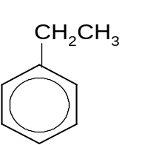 will produce CO₂ gas which gives a white ppt with Ca(OH)₂(aq).
 |  |  |  | (ii) |  | Test: Add aqueous alkaline iodine to both compounds and heat.  Observations:  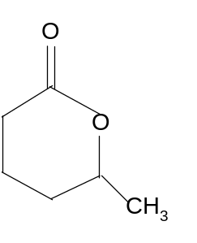will give a yellow ppt with aqueous alkaline iodine.
7. |  | (a) |  | (i) |  | Weak acids dissociate partially in water.
 |  |  |  | (ii) |  | 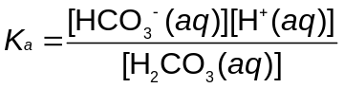; mol dm⁻³
 |  |  |  | (iii) |  | Addition of H⁺ :  HCO₃– + H⁺ ⎯→ H₂CO₃  Addition of OH–:  H₂CO₃ + OH– ⎯→ HCO₃– + H₂O  With a large reservoir of H₂CO₃ and HCO₃– present, since the amount of H⁺ and OH– added is small, there will be insignificant changes in [H₂CO₃] and [HCO₃–].  Hence pH is maintained.
 |  |  |  | (iv) |  | = 7.94 × 10⁻⁷  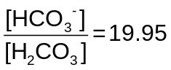(or ratio 20:1)
 |  |  |  | (v) |  | Yes. K_{c} changes with temperature and an increase in temperature will cause the position of the equilibrium to shift, therefore changing the concentrations of the ratio of hydrogen carbonate ion and carbonic acid in plasma.
 |  | (b) |  | (i) |  | The melting points from Na to Al are high due to their giant metallic structures and melting involves overcoming strong metallic bonds. The melting point increases from Na to Al as the strength of the metallic bond increases from Na to Al due to an increasing number of mobile valence electrons used in bonding.  Si has the highest melting point due to its giant molecular structure. A large amount of energy is required to break the strong covalent bonds [1] in Si.  P₄, S₈, Cl₂ and Ar have lower melting points since they are simple molecules with weak van der Waals’ forces between molecules. The strength of the van der Waals’ forces increases with the size of the electron cloud in the order of Ar, Cl₂, P₄, S₈.
 |  |  |  | (ii) |  | Ga₂O₃ has a giant ionic structure.  Ga₂O₃ is amphoteric.  Ga₂O₃(s) + 6HCl(aq) → 2GaCl₃(aq) + 3H₂O(l)  Ga₂O₃(s) + 2NaOH(aq) + 3H₂O(l) → 2NaGa(OH)₄(aq)
 |  | (c) |  | No. of mol of Cl atoms in MCl₃  = No. of mol of AgCl formed  = 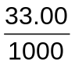 × 0.0500  = 1.65 × 10⁻³ mol  No. of mol of MCl₃ used  = 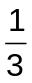× No. of mol of AgCl  = × 1.65 × 10⁻³  = 5.50 × 10⁻⁴  Molar mass of MCl₃  = 0.100/5.50 x 10⁻⁴  = 181.8 g mol⁻¹  A_{r} of M  = 181.8 – 3(35.5)  = 75.3  = 75 (to nearest whole number)  M is As (arsenic)
8. |  | (a) |  | (i) |  | Substitution  Reagents & conditions required: aqueous KOH, heating.
 |  |  |  | (ii) |  | Ethanolic KCN  heat  Dil. H₂SO₄  Heat  CH₃CH₂Cl CH₃CH₂CN CH₃CH₂COOH
 |  |  |  | (iii) |  | CH₃CH₂COOCH₂CH₃  Reagents and conditions required: Conc. H₂SO₄, heat.
 |  |  |  | (iv) |  | CH₃CH₂OH CH₃CH₂O⁻ + H⁺  CH₃CH₂COOH CH₃CH₂COO⁻ + H⁺  Propanoic acid dissociates in aqueous solution to form the propanoate ion, which is resonance stabilised, compared to the ethoxide ion formed from the dissociation of ethanol, which has a negative charge localised on the O⁻ ion.  Hence propanoic acid is more acidic than ethanol.
 |  | (b) |  | (i) |  | Refrigerants / aerosol propellants / fire extinguisher
 |  |  |  | (ii) |  | The C−F bond is stronger as the fluorine orbital is smaller in size than chlorine orbital, resulting in a more effective overlap of orbitals.
 |  |  |  | (iii) |  | Chlorine atoms are not used up in these reactions (chlorine atoms do not appear in the net reaction / are regenerated).  OR  Chlorine radicals react with ozone to destroy the ozone layer.
 |  | (c) |  | (i)
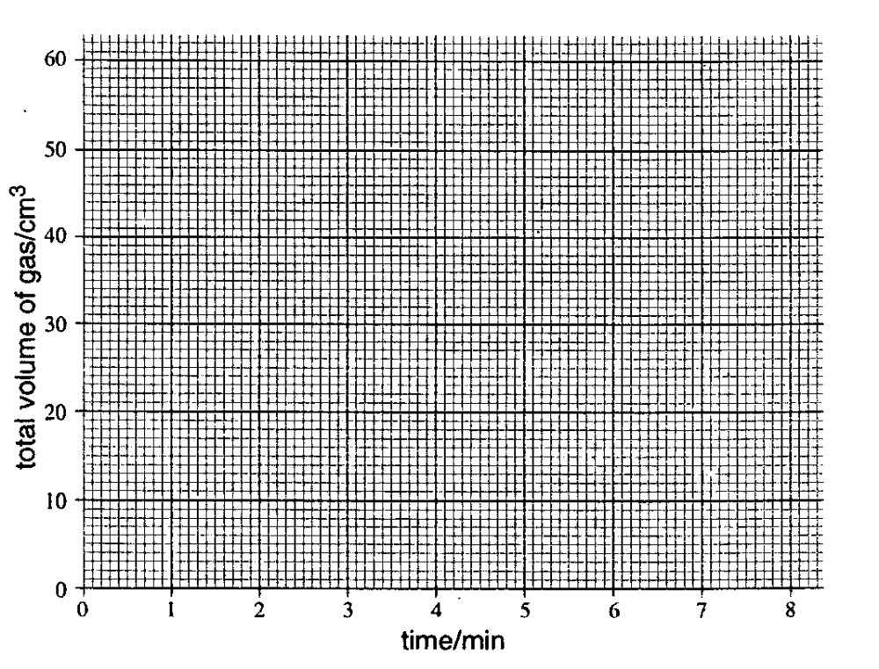

First order with respect to benzenediazonium chloride.

 |  |  |  | (ii) |  | Water is present in large excess and will appear to be zero order with respect to the reaction.
 |  |  |  | (iii) |  | Amount of nitrogen evolved  = 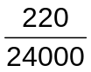 = 9.167 × 10⁻³ mol  Mass of benzenediazonium chloride required  = 9.167 × 10⁻³ × 141.5 = 1.30 g

